**Great Job Lou! 200/200**

Database Driven Web Development

**Final Project**

Presentation Instructions

horizontal line

**Eventually, you will find yourself having to sell either yourself or your project to a prospective employer or customer. Making a good presentation can be a key part of this process. As such, we want you to get some practice with presentations in a safe academic environment. This also gives you a chance to show off the project you built to your classmates.**

Create a presentation for your final project. Your presentation will be delivered on the last day of class. Your presentation must include a live demo of your final project.

The below checksheet sheet must be fully completed for this portion of the project.

**1. PowerPoint Presentation (100pts)**

**Your target audience for this presentation is potential employers. This is your opportunity to “sell yourself” to get a job through the code that you’ve worked on all semester. Ideally, during the interview process, you would be able to get a potential employer to watch your presentation on YouTube and review your code repos. A good project can be the difference between landing a job and not.**

Remember why we chose this project in the first place:

[The 1 Coding Project Idea Guaranteed To Get You A Software Development Job](https://youtu.be/oC483DTjRXU)

You need to create a short **PowerPoint style** presentation for this project.

If you do not have PowerPoint installed, you can download it for free from [**Office 365.**](https://www.office.com/)

Use your Ranken login for the Office 365 portal.

* Slides include information about you and the project. (10pts)
  + Include your name
  + Include the current year and semester
  + Include the name of your project
* Slides include background of project (20pts)
  + In your own words, why did you take on this particular project?
  + What did you learn from this project?
  + What would you do differently next time?
* Slides include a review of the Technology Stack (20pts)
  + Get screenshots of each “layer” of the stack
  + This can be screenshots of your code or user interface.
    - **GCLOUD**
    - **Database ERD**
    - Node.js Application (back end) Tier
      * **Including Permissions Table**
    - React.js Front End
* Slides include a brief overview of the project's key features (20pts)
  + Include a bulleted list of features
    - What can your software DO?
* Slides include at least 1 screenshot from your live project (10pts)
  + Choose which screen(s) represent your project the best
* **5** slides minimum (10pts)
* Font sizes on all slides must be at least **14pt** (10pts)
* Presentation should be between **15** mins in length or longer (including a live demo)
* The last slide should say “Live Demo” which is when you switch from PPT presentation to giving a LIVE presentation of your software. Live demo should be a thorough overview of all features in your Issue Tracker

**2. Recording Instructions**

To help presentations go smoothly, I would like all of you to:

1. Pre-record your **presentation** and **demo.** This can be done in 1 video or in 2.
2. Combine both of these recordings into one video file. Your slides must be presented first and your demonstration must be second.
3. Upload it to YouTube as either an **Unlisted** or **Public** video. It must be marked as **"Not For Kids"** so that I can add it to my playlist.
4. And provide me with a **link** to the published video. (Via direct message in Discord.)
5. The grading rubric for the recorded presentations is on **Page 6.**

# Screen Recording Software

You can use your screen recording software of choice for this.

* [**https://streamlabs.com/**](https://streamlabs.com/) **-** StreamLabs is a very popular recording software. Streamlabs in my experience is the easiest to learn and use.
* Personally, I use **OBS (**[**https://obsproject.com/**](https://obsproject.com/)**)** to record my lectures / screen. OBS is free and open-source. I like OBS because it has the ability to pause and I didn’t see that option in Streamlabs.
* **Nvidia ShadowPlay (**[**https://www.nvidia.com/en-us/geforce/geforce-experience/shadowplay/**](https://www.nvidia.com/en-us/geforce/geforce-experience/shadowplay/)**)** also works well for recording your screen. Shadowplay is free and works with any Nvidia graphics card.
* **Fraps (**[**https://www.fraps.com/**](https://www.fraps.com/)**)** offers a free version, but I would not recommend it.
* *Many other options available online, but pay attention to licensing terms.*
* *Let me know of any other options you find and use.*

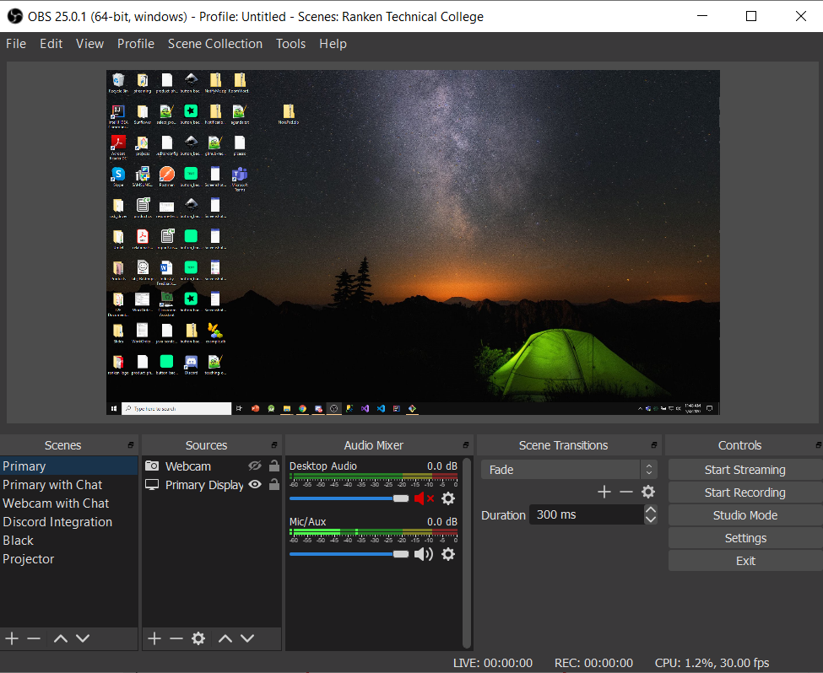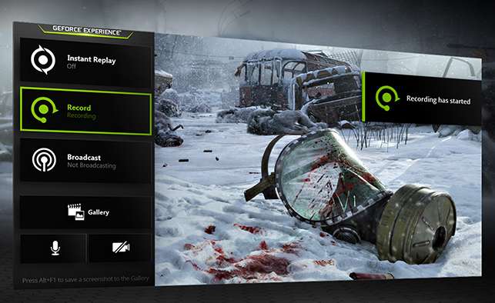

# Configuration for Graphics Cards

**To record some applications (especially apps running in fullscreen, such as powerpoint) you may need to switch them to run on the integrated graphics chip. See articles below for further troubleshooting.**

**Windows 10 Graphics Settings (for OBS and other screen recorders)**

<https://obsproject.com/forum/threads/solution-for-black-screen-display-capture-even-after-performing-the-steps-on-obs-forum.112109/>

**Configure your system for Game/Window Capture (for OBS and other screen recorders)**

*For NVIDIA graphics cards*

[*https://obsproject.com/wiki/Laptop-Troubleshooting#for-nvidia-based-laptops*](https://obsproject.com/wiki/Laptop-Troubleshooting#for-nvidia-based-laptops)

*For AMD graphics cards*

[*https://obsproject.com/wiki/Laptop-Troubleshooting#for-amd-based-laptops*](https://obsproject.com/wiki/Laptop-Troubleshooting#for-amd-based-laptops)

**Below is a screenshot of how to do this in the Nvidia control panel.**

**(However this seems to no longer work in Windows 10.)**

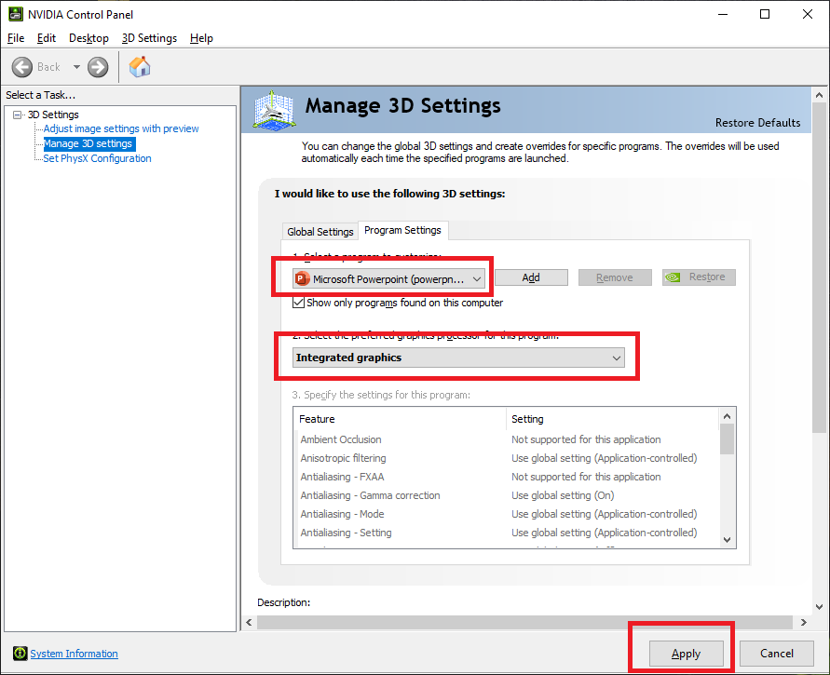

# Video Editors

To edit the audio/video after recording and splice multiple clips together, you'll need a video editor. There are several free and open-source video editors available online.

* **Shotcut (**[**https://shotcut.org/**](https://shotcut.org/)**)** is one of the better free options I've used.
* *Many other options available online, but pay attention to licensing terms.*
* *Let me know of any others you find and use.*

# Ask for help

If you have any issues with recording your presentation, audio, or editing after don't hesitate to ask for help. I'm here to lend a hand when needed.

**3. Live Demo/Recording Grading Rubric (100pts)**

*The presentations will be graded using this form.*

You will need to record, edit and upload your presentations to **YouTube.**

All of the following checklist items must also be completed for approval.

* Microphone levels have been tested and are in the proper range.
* Presentation was recorded, and slides were used.
* Demo has been recorded, and the deployed application was used.
* Presentation and demo are put into a single video.
* Slides Presentation is first, Live Demo is at the end.
* Combined presentation has good audible audio levels.
* Combined presentation is **10-15** minutes in length.
* Combined video uploaded to **YouTube.**
* Video marked as either **Unlisted** or **Public.**
* Video is marked as **"Not For Kids"** so that it can be added to my playlist.
* YouTube link for published video sent to instructor (direct message in Discord)

Your presentation will be graded on the following criteria:

* Content
  + Slides were covered. (10pts)
  + Live demo of application given. (20pts)
  + Application is free of any noticeable bugs or errors. (20pts)
  + Highlight the Custom Functionality you added to your project (10pts)
* Recording
  + Recording Draft and Final Video submitted to instructor (10pts)
    - Draft must include written feedback from 3rd party
  + Recording is uploaded to YouTube and link shared with the instructor (10pts)
  + 15 minute minimum duration was met (10pts)
* Similar to a Mock Interview, when you record yourself, I want you to share your recording with a friend, family member or trusted acquaintance to gather their feedback. I want you to consider their feedback and implement some of their suggestions. (10pts)